Import Data using Transform Maps (Spreadsheet)
PHASE 1: BRAINSTORMING & IDEATION PHASE

Project Idea :
The project idea is “Import Data Using Transform Maps (Spreadsheet)” in the ServiceNow platform.
This project focuses on importing structured employee data from an external Excel spreadsheet into ServiceNow using Import Sets and Transform Maps.

Problem Identification :
In real-world organizations, employee information may be maintained in Excel spreadsheets. Manually entering a large amount of employee data into ServiceNow can be time-consuming and may result in data entry errors.
Therefore, an automated data import process is required to transfer employee information from a spreadsheet into ServiceNow efficiently and accurately.

Proposed Solution :
The proposed solution is to:
- Prepare employee data in an Excel spreadsheet.
- Load the spreadsheet data into a ServiceNow Import Set table.
- Create a Transform Map.
- Map the source fields with the target table fields.
- Transform the data into the target Employee Test table.
- Validate the imported records.
- Use Coalesce to avoid duplicate records.
- Create reports and dashboards for employee data.

Objective
The main objective is to understand and implement the complete data import process in ServiceNow, from spreadsheet preparation to data transformation and validation.

Prepare the sheets

- Open New Google Spreadsheet
- Create New Google Spreadsheet with sample data as shown below

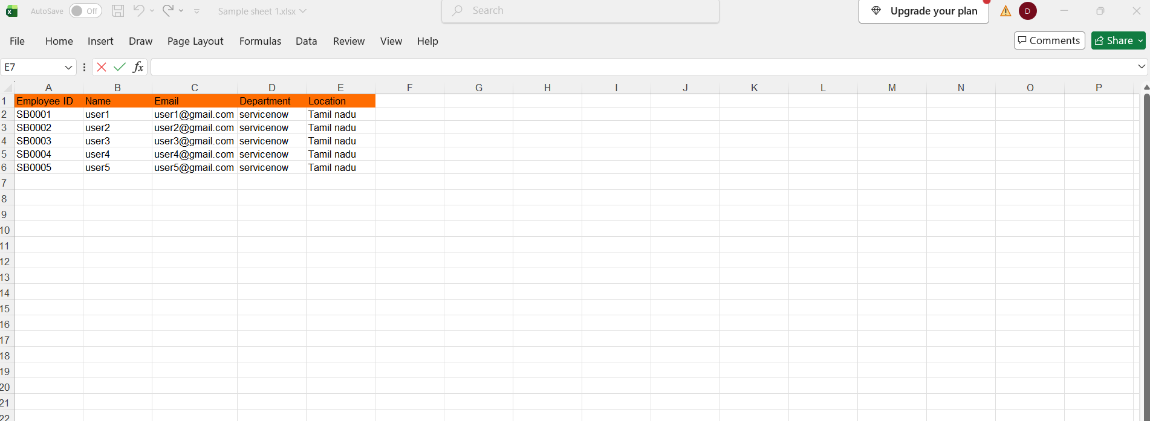

- Download the spreadsheet as Sample Spreadsheet.xlsx format.

